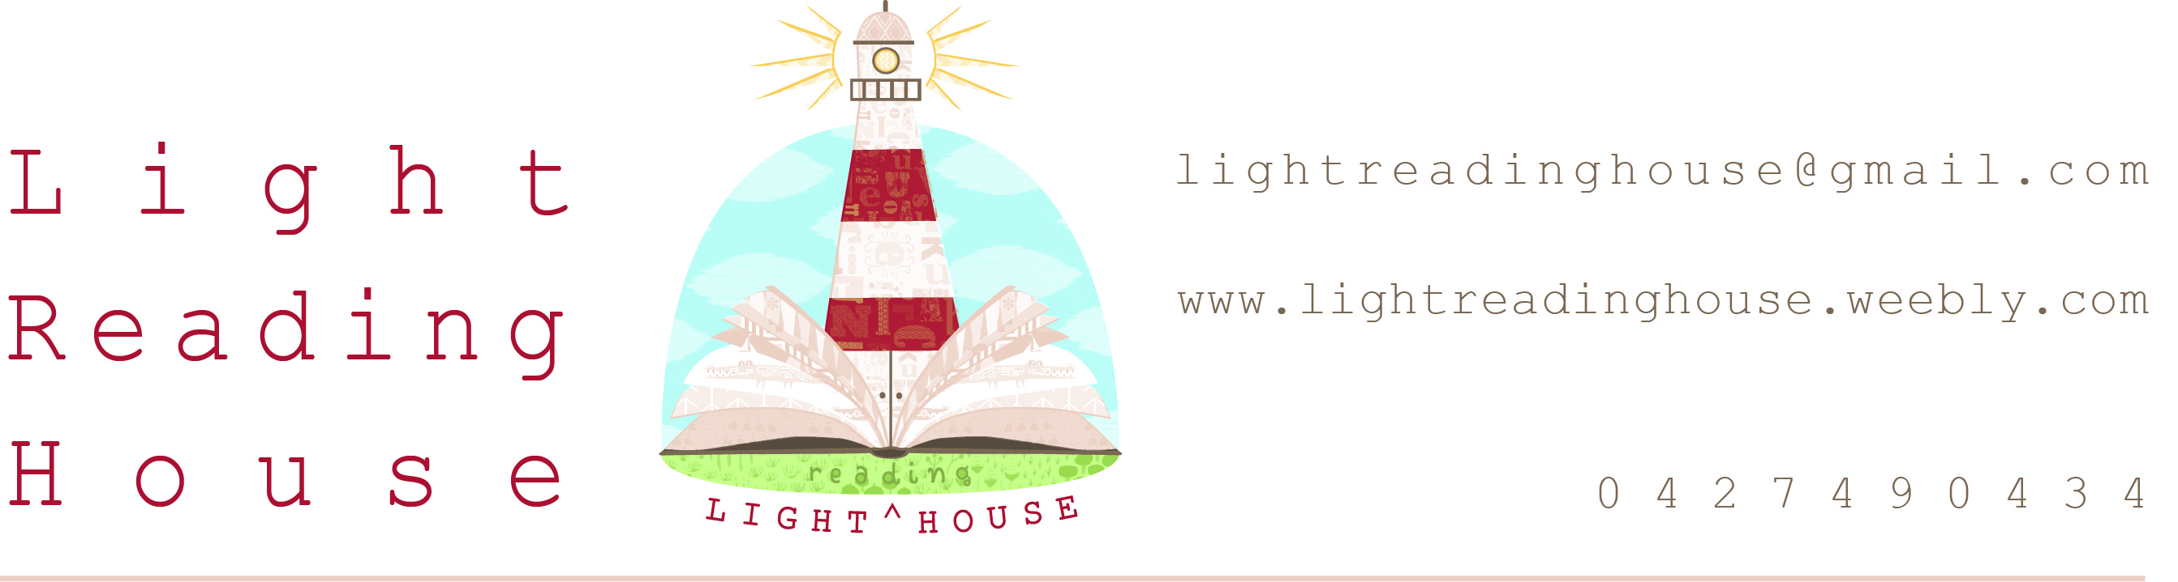
 | Wednesday 21st Sept | Thursday 22nd Sept | Friday 23rd Sept
Session 1  10am-12.00 | A Perfect World –  Perfect stories come from perfect places – or do they!?  Have some fun imagining the most fun, silly and whacky places to set your stories.  Junior* | Riddle Me This –  My answer is easier than my questions… what am I?  A riddle! Come and learn how to write your own and keep everyone guessing through the holidays!  Intermediate* | Urban Myths –  These myths are true, honestly… We heard them from a friend of a friend of ours!  Hear some of the oldest and creepiest and work out the real from the fake… then have a go at creating your own!  Senior*
Session 2  12.30-2pm | Story Sounds –  Make your favourite stories come to life by adding your very own sound effects!  Junior * | Lighthouse Letters –  Letter writing with a twist! Write letters to unexpected recipients and give your readers a giggle…  Intermediate* | Make Me Laugh –  Think of yourself as a comedian? Like to laugh? Put your funny bone to the test and make your own comedic comic.  Senior*

Lighthouse Workshops

Come along and develop your writing skills in a fun and relaxed environment! You will practice many different creative writing techniques and come home armed with tools to continue writing at home! Workshops are capped at 15 students and are aimed towards various ages from 6-16 years. Participants are invited to make a voluntary contribution of $5 to cover costs.
Bookings essential.

*Age Groups (guide only):

Junior - 6-8 years
Intermediate - 9-12 years
Senior - 13-16 years

